**A PROJECT REPORT ON**

# Stock Market Learning

###### SUBMITTED TO :

**Geetanjali Colleges of computer science**

**And commerce (BBA)**

###### AFFILIATED BY :

Saurashtra University

###### ACADEMIC YEAR :

2023-2024

**PROJECT GUIDE :**

**Prof. Kishorsinh vala**

**PREPARED BY :**

**Tankariya Harsh Jiteshbhai**

#### ACKNOWLEDGEMENT

* First of all I am sincerely thanked to Saurashtra University for giving a project as a particular subject.
* I am also greatly grateful to our **Geetanjali Group of colleges**.
* I am also greatly grateful to our college. I would like to thanks **Prof. Brijesh Shah (HOD)** for providing us opportunity to prepare this project.
* To complete this project many persons help us. But we are specially thanked to **Prof. Kishorsinh vala** for guiding our project analysis and development. They help our conceptualized the idea of the project and helped us streamline our work by providing us with every facility required.
* Thank to all

Your Faith Fully, Harsh Tankariya

PREFACE

In 21st Century of Technology, Computer and related service is the most useful, automatic and highly speed of work. B.C.A is course in which practical aspect is important as theoretical aspect. In the present world importance of education is increasing. The project training in a student’s life is like a live experience in the industry. If we have experience then & then we get top of the level.

Most Important Factor of B.C.A Course is Project Work. The Project Work is Must for Every Student in Different Government or Private Organization during the Study Period.

I am developing project in 6th Semester of B.C.A I am student of Geetanjali Group of Colleges Is Affiliated with Saurashtra University, Rajkot.

I am create this project dynamic and in this project I provide insert, update and delete operation on admin side and select at client side so user can easily show site and give feedback. In client side only feedback can add other any page can’t perform add operation.

I have gone through and study necessary information, which is collected and presented in this report. We are trying our best in this project. I have taken almost care that are information provided in the project is true and project is in a smooth running condition and error free.

**INDEX**

|  |  |  |
| --- | --- | --- |
| **SR.NO** | **TOPIC NAME** | **PAGE NO.** |
| 1 | Project Profile | 1 |
| 2 | Software Development Life Cycle (SDLC) | 2 |
| 3 | System requirement   1. Hardware Requirement 2. Software Requirement | 5 |
| 4 | Data Dictionary | 7 |
| 5 | E-R Diagram | 10 |
| 6 | Data Flow Diagram | 11 |
| 7 | Screen Shots | 12 |
| 8 | Test cases of project | 23 |
| 9 | Future Enhancement | 24 |
| 10 | Limitation of project | 25 |
| 11 | Webliography | 26 |

## Profile of project

|  |  |
| --- | --- |
| **Project Title :** | Stock Market Learning |
| **Development Software :** | Visual Studio 2022 |
| **Front End :** | ASP.NET |
| **Backend :** | SQL SERVER **,** C# |
| **Academic Year :** | 2023-2024 |
| **Developed By :** | Harsh Tankariya |
| **Submitted To :** | Geetanjali College |
| **Documentation Tool :** | Microsoft Word |
| **Operating System :** | Windows |

#### Software Development Life Cycle (SDLC)

1. Project Initiation:

* Define the project's goals, objectives, and scope for the stock market learning website.
* Identify key stakeholders and establish communication channels.
* Perform a feasibility study to ensure the viability of the project.

#### Planning:

- Develop a project plan outlining tasks, timelines, and resource allocation.

* Identify and allocate necessary resources, including developers, content creators, and subject matter experts.
* Determine the technology stack, specifying the use of ASP.NET for web development.
* Identify potential risks and create a risk mitigation plan.

#### Requirement Gathering:

- Collaborate with stakeholders to gather detailed requirements for the stock market learning website.

* Define features such as user registration, course management, interactive learning modules, quizzes, progress tracking, and forums.
* Document user stories, use cases, and functional specifications.

#### System Design:

* Create a system architecture design for the website.
* Plan the website's user interface (UI) design and user experience (UX).
* Define security measures to protect user data and ensure a secure learning environment.

#### Development:

* Develop the stock market learning website using ASP.NET.
* Develop features for browsing and enrolling in courses, accessing learning materials
* Implement responsive design for various devices and browsers.
* Conduct unit testing and debugging to ensure code quality.

#### Testing:

* Perform functional testing to ensure all features work as intended.
* Test the performance of the website to ensure optimal speed and responsiveness.
* Fix bugs and issues identified during testing.

#### Deployment:

* Prepare the production environment for hosting the stock market learning website.
* Deploy the ASP.NET application on a web server.
* Configure databases and web servers for optimal performance.

#### Maintenance and Support:

* Establish a process for ongoing maintenance and support.
* Address user feedback and bug reports promptly.
* Regularly update the website with new courses, content, and features.
* Monitor website performance and security.

#### Project Closure:

* Evaluate the success of the project against initial objectives.
* Create documentation for future reference and maintenance.
* Conduct a post-implementation review with stakeholders.
* Archive project files and release resources.

# SYSTEM REQUIREMENT

There are two types of system requirement.

-Hardware

-Software

###### Hardware:-

* Processor:-

8 Bit, 2 core, 1.2 GHz or higher.

* RAM:-

4GB for development and evaluation use or more

* Hard disk:-

100 MB or More

###### Software:-

* Platform:- Windows
* Operating system:-

Windows 10 profession or any

* Front End tool:- ASP.NET
* Back end tool:- SQL server
* Editing tool:-

Microsoft visual Visual Studio 2022

* Browser:-

Internet Explorer or Mozilla Firefox or

Google Chrome or Any browser

DATA DICTIONARY

Database Tables :

* admin
* feedback
* market_news_table
* ipo_news _table
* sme_news_table

admin:-

|  |  |  |
| --- | --- | --- |
| **Field Name** | **Data Type** | **Constraints** |
| user_id | int | - |
| username | varchar(50) | - |
| password | varchar(50) | - |

Feedback:-

|  |  |  |
| --- | --- | --- |
| **Field Name** | **Data Type** | **Constraints** |
| id | int | - |
| name | varchar(50) | - |
| email | varchar(50) | - |
| message | varchar(50) | - |

### Market_news_table:-

|  |  |  |
| --- | --- | --- |
| **Field Name** | **Data Type** | **Constraints** |
| newsdate | varchar(50) | - |
| newst | varchar(Max) | - |
| newsd | varchar(Max) | - |

ipo_news_table:-

|  |  |  |
| --- | --- | --- |
| **Field Name** | **Data Type** | **Constraints** |
| Companyname | varchar(50) | - |
| opendate | varchar(Max) | - |
| closedate | varchar(Max) | - |
| Listingdate | varchar(Max) | - |
| lotsize | varchar(Max) | - |
| Allotment | varchar(Max) | - |
| Listingat | varchar(Max) | - |
| Totalsize | varchar(Max) | - |
| Creditofsharetodemat | varchar(Max) | - |
| Initiationofrefunds | varchar(Max) | - |

### sme_news_table:-

|  |  |  |
| --- | --- | --- |
| **Field Name** | **Data Type** | **Constraints** |
| Companyname  Companyname | varchar(50) | - |
| opendate | varchar(Max) | - |
| closedate | varchar(Max) | - |
| Listingdate | varchar(Max) | - |
| lotsize | varchar(Max) | - |
| Allotment | varchar(Max) | - |
| Listingat | varchar(Max) | - |
| Totalsize | varchar(Max) | - |
| Creditofsharetodemat | varchar(Max) | - |
| Initiationofrefunds | varchar(Max) | - |

#### E-R Diagram

An entity Relationship Diagram (ERD) is a data modeling technique that graphically illustrates an information system’s entities and the relationship between those entities . An ERD is a conceptual and representation model of data used to represent the entity from work infrastructure .

Admin side

Home page

Learnin page

Market news

About page

Contact us

Exam page

Admin side

User review

Exam page

Market

news

ipo

news

sme news

#### DATA FLOW DIAGRAM

Admin Side:-

Market news

Ipo news

Sme news

login

User review

Candidate names

Client Side:-

Ipo news

Market

news

Sme news

Learning

page

Index page

Contact us

About page

Exam page

Client Side:-

### SCREEN SHOT

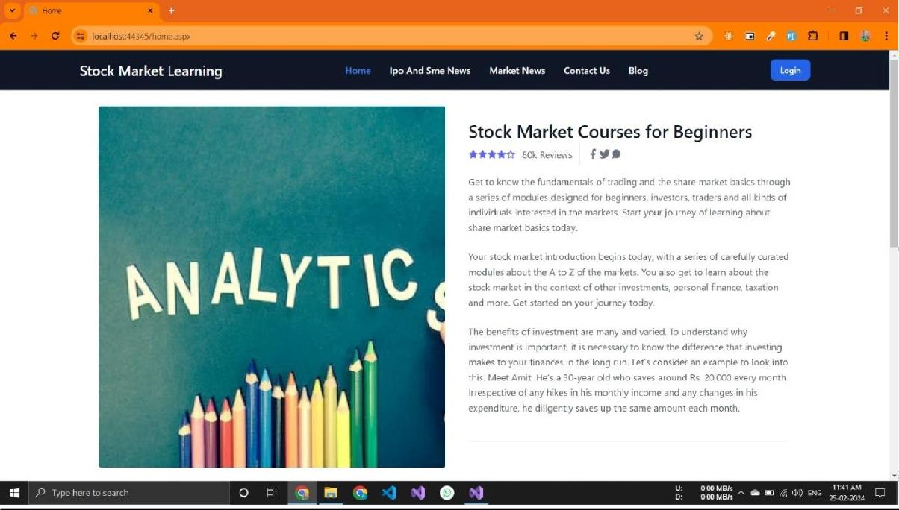

Home page :-

* This is home page of website.
* In This Page You Show Stock Market Basic Information
* This Page You Learn Basic Information of Stock

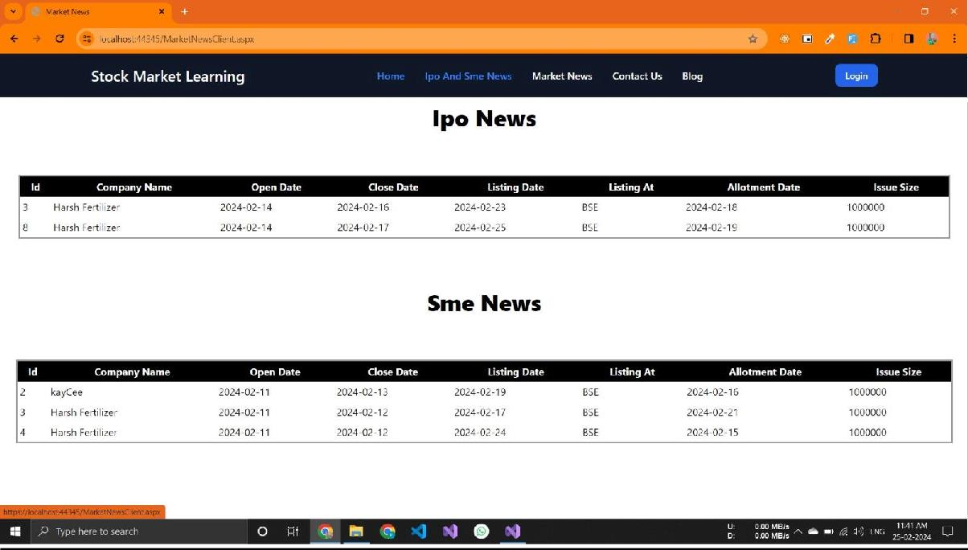

Ipo And Sme News page :-

* User can see all the ipo and sme details here like company name,price,open date,close date,allotment date and listing date.
* this page user is the read all about information IPO and

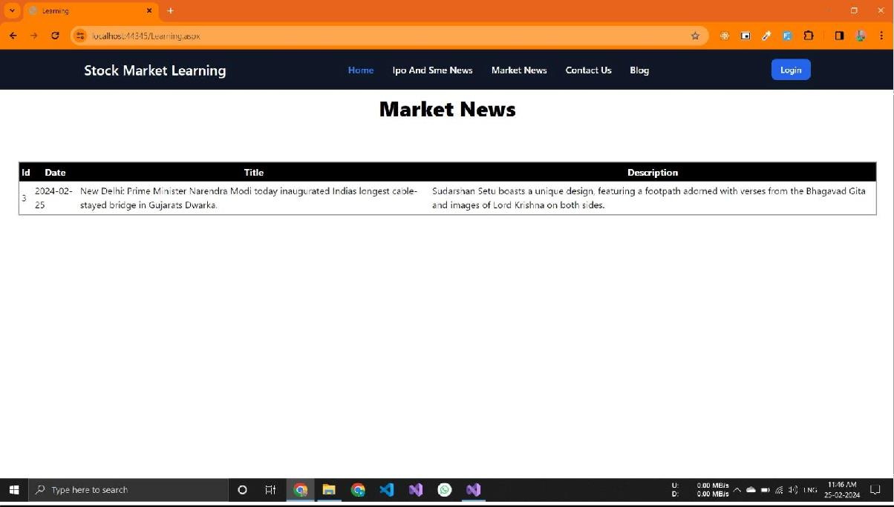

Market News page :-

* This Is a Market News Page
* In This Page User Is Read Market News
* User Can Read Latest News In This Batch

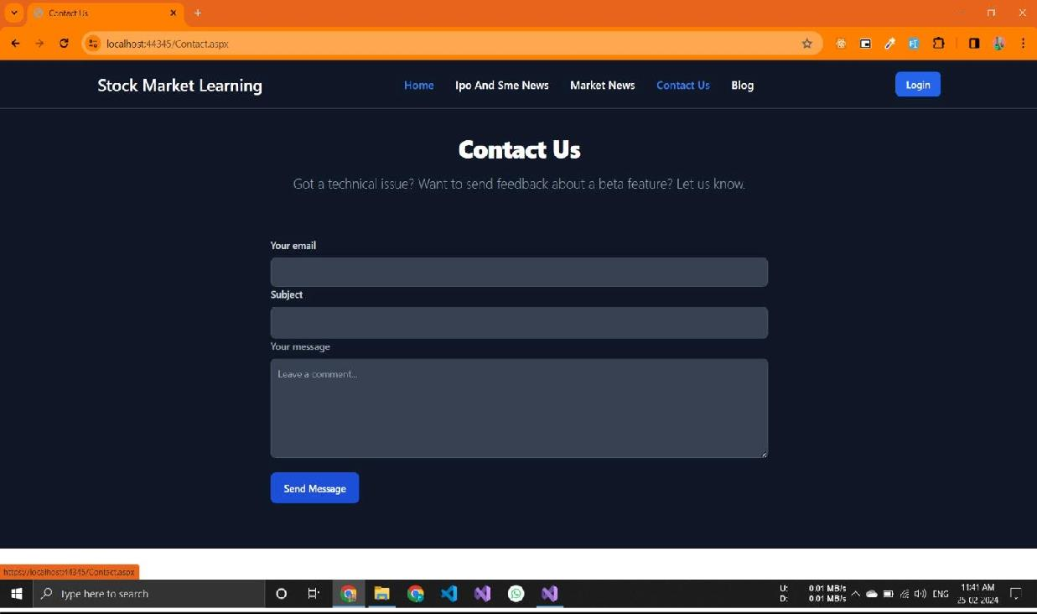

Contact Us page :-

* This Is a Contact Page
* In This User Can Send Its Feedback About Webside

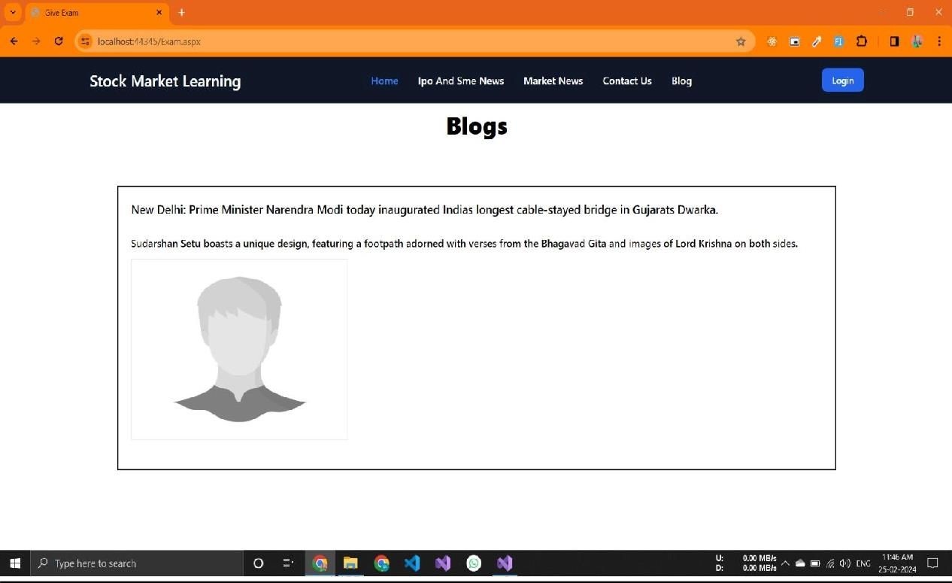

Blog page :-

* In This Page User Can Learn About Stock Market Basic To Advance
* This Page Are Fully Dynamic Admin Is Add a blogs To Admin Side
* Admin Is Add Blogs About Learn Stock Market

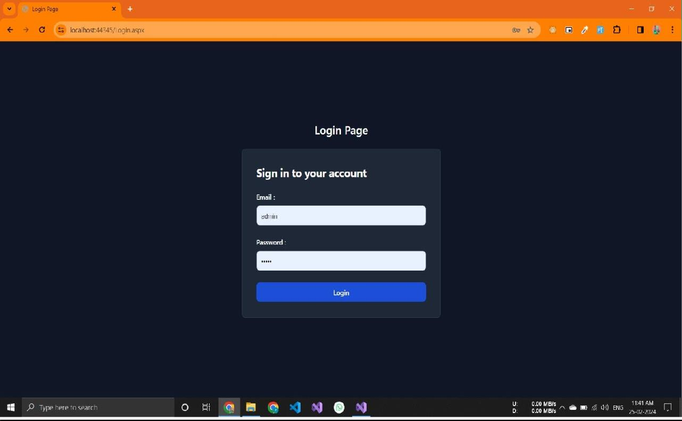

Login page :-

* This Is a Admin Login Page
* In Is Page Is Only Admin Login Not Any User

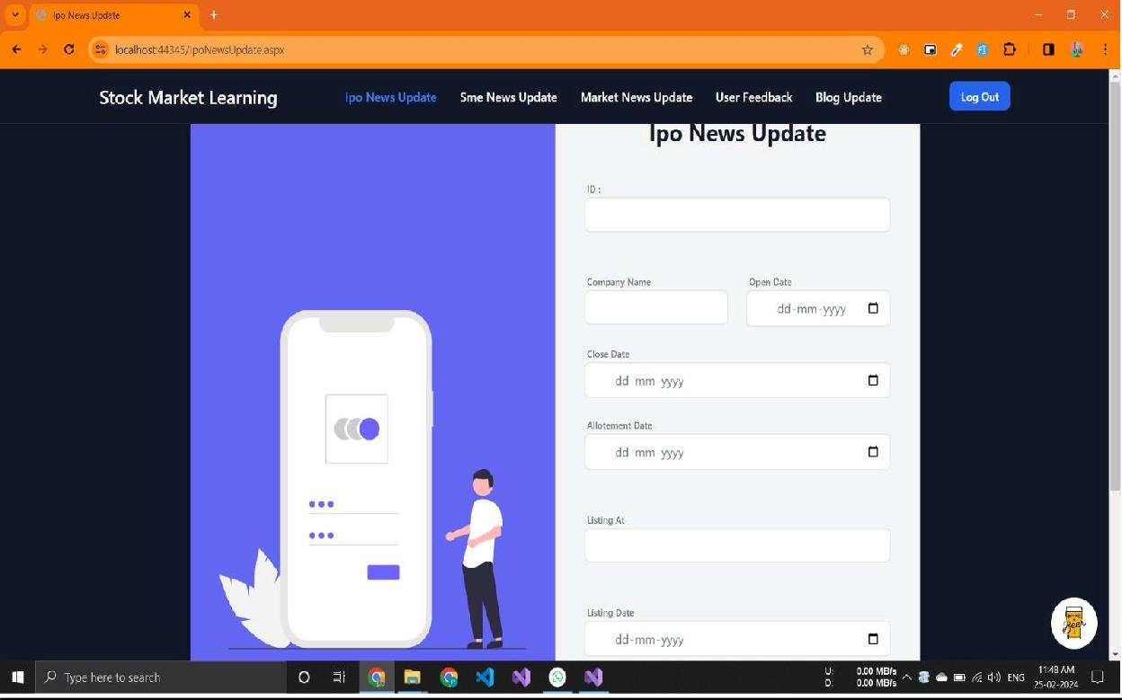

Admin :-

Ipo Update page :-

* This Is a Ipo news Update Page
* In This Page Admin Are Add IPO Update IPO And Delete IPO News To This Page
* Admin Is Add Details Here Like Company Name,Price,Open Date,Close Date,Allotment Date And Listing Date.

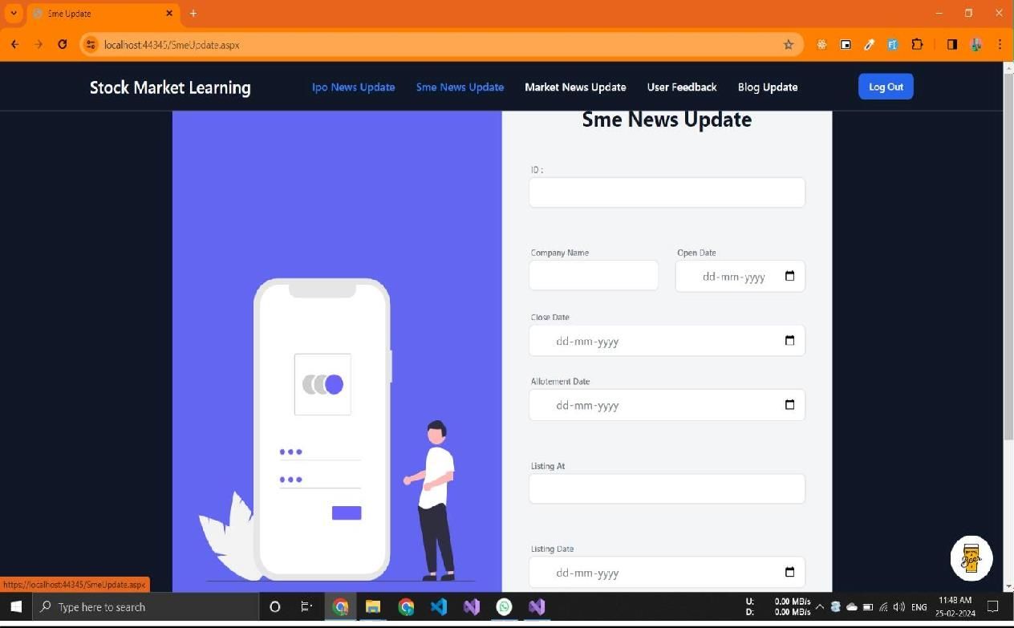

Sme Update page :-

* Thi Page Is Same To Ipo News Page But in Page Are Add News To Sme
* In This Page Admin Are Add SME Update SME And Delete SME News To This Page
* Admin Is Add Details Here Like Company Name,Price,Open Date,Close Date,Allotment Date And Listing Date.

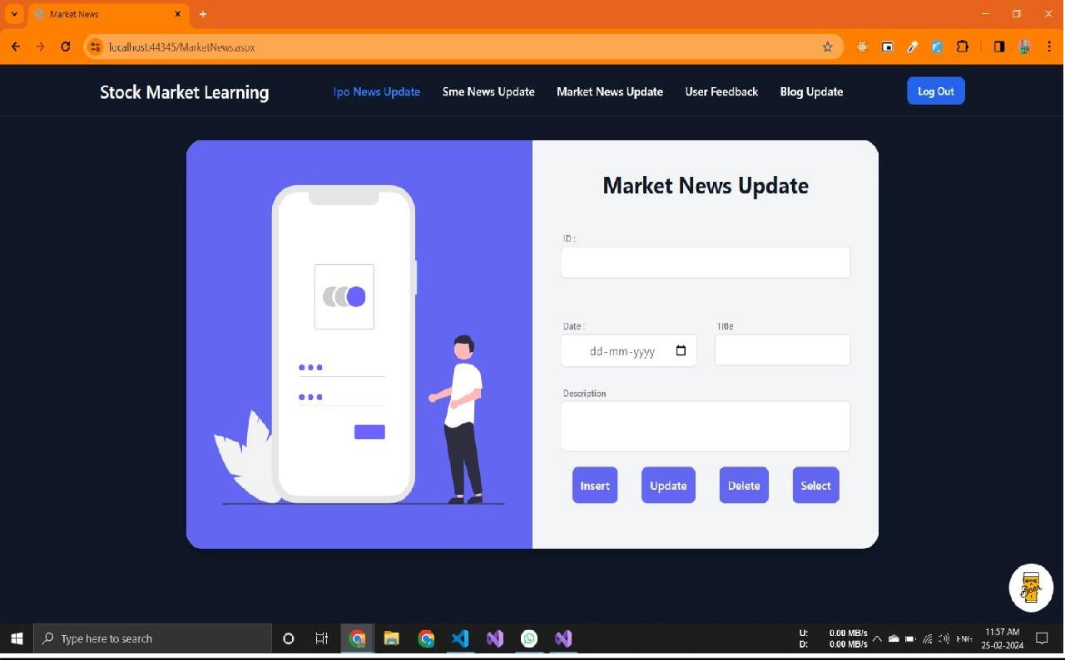

Market News page :-

* In This Page Admin Are Add Market News Update News And Delete News News To This Page
* In This Page Admin Is Add Latest News To News Date And News News title And News Detail

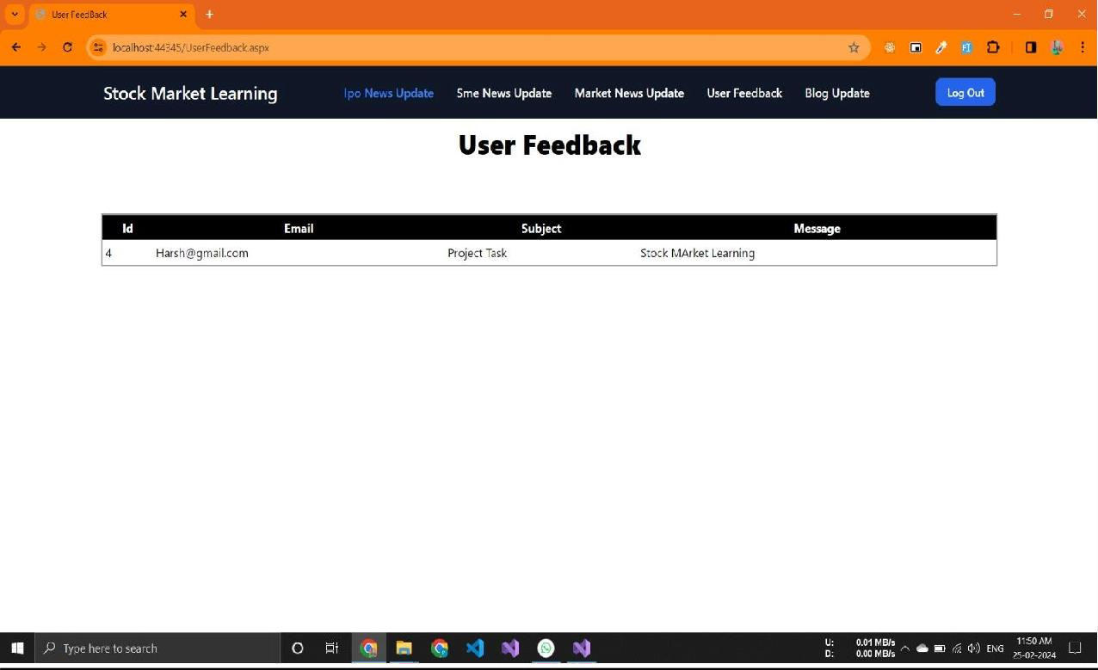

User Feedbackpage :-

* In This Page Admin Is Show Give User Feedback to WebSide
* admin is show the details user like a email contact number or message

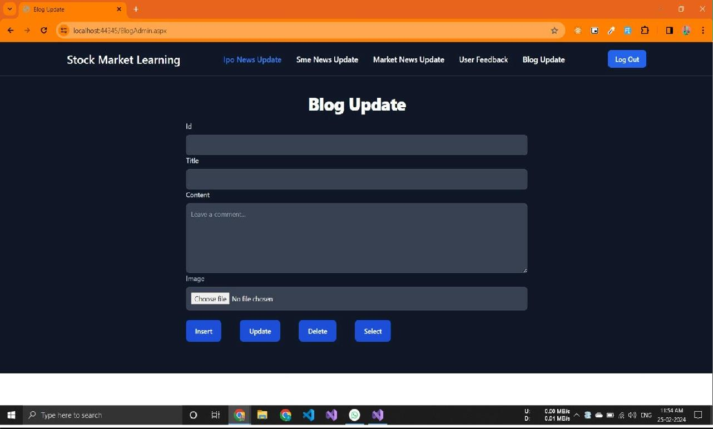

User Feedbackpage :-

* In This Page Admin Are Add Blog Update Blog And Delete Blog To This Page
* admin Are Add Blog About Stock Market learning In This Website

Test cases

|  |  |  |  |
| --- | --- | --- | --- |
| **Case name** | **Case description** | **Actual output** | **Test result** |
| Login | A Window with a two text box user name or password . | Write correct username or password and login successfully | pass |
| Dashboard | A page that use to insert data | A page thst use to insert whole website . | Pass |
| News page | A page that display databace content | A page that display all news information | pass |

Future Enhancement

* we will provide a facility to use our each get a certificate to exam website.
* We will provide facility to user can check their ipo and sme allotment status from our website.
* we will provide a more learning stock market tools in in website
* we will start online lecture on stock market learning to the new students or new users

#### Limitation of project

##### User read news it can not download news PDF .

* + User can not view image for news .

##### User can not redirect any other news link .

* + our candidate is not able to get the online certificate of the given exam

### WEBBLIOGRAPHY

[**https://www.w3schools.com/**](https://www.w3schools.com/)

We use this website to fontend design.

[**https://timesofindia.indiatimes.com/**](https://timesofindia.indiatimes.com/)

We use to read news for this website.